***Documentation***

**Title: Digital Skills Festival 2024**

**Project description:**

The Digital Skills Festival, was organized by the Crosscience Initiative with support from FLOSSK, brought together nine universities and one business incubator in Kosovo. This festival offers a diverse program to help participants learn new digital skills, foster academia-industry collaboration, and develop business solutions. The 2024 year of the festival the focus was on the Twin Transition, educating participants on the simultaneous transition to a green and digital economy.

**Activities:**Key activities:

* Coordinating with the Crosscience Consortium,
* Organizing hackathons
* delivering university presentations
* Preparing documentation
* Logistical support, accommodations, venue setup
* Technical support.

**Photos:**

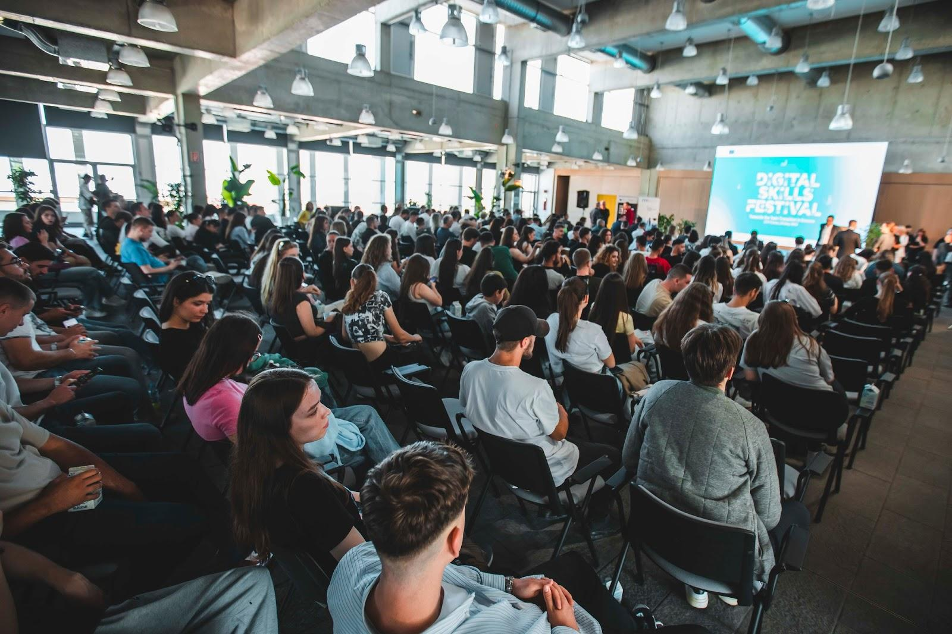

**Beneficiaries:**

In the Digital Skills Festival, The students had the chance to show off their skills and creativity and more than 700 students attended.

**Partners:**

* Innovation and Training Park Prizren -ITP
* Universiteti i Prishtinës
* Universiteti "Ukshin Hoti" Prizren
* Universiteti "Isa Boletini"-Mitrovicë
* UBT - Higher Education Institution
* Riinvest International
* RIT Kosovo
* Kolegji Universum
* Universiteti i Shkencave të Aplikuara në Ferizaj
* Universiteti "Kadri Zeka" Gjilan
* Kolegji AAB
* Venture UP.

**Budget:  
€5,960.00**

**Project duration**:

May of 2024

*This document is FLOSSK intellectual property - Do not share without authorization from FLOSSK.*